**AI-Powered Drug Discovery Using Deep Learning and Real-Time Data Visualization**

**1. Introduction:**

Drug discovery is a complex and time-intensive process that can benefit significantly from the integration of artificial intelligence (AI) techniques. Recent research demonstrates how deep learning models can predict molecular properties, thereby accelerating early-stage drug development. In this work, we implement a deep learning-based approach for molecular property prediction, supported by interactive data visualization tools to aid researchers in analysing and interpreting results efficiently.

**2. Methodology:**

The proposed system follows a structured approach for AI-assisted drug discovery:

* **Dataset Preparation:**  
  A molecular dataset is simulated containing properties such as Molecular Weight, LogP (lipophilicity), and Binding Affinity.
* **Deep Learning Model:**  
  A regression model is developed using a feed-forward neural network to predict Binding Affinity based on molecular properties. The model consists of:
  + Input Layer with two features
  + Hidden Layer with ReLU activation and dropout
  + Output Layer providing Binding Affinity prediction
* **Visualization:**  
  The results are visualized using scatter plots to illustrate the relationship between molecular properties and predicted affinity.
* **Real-Time Dashboard:**  
  A web-based dashboard is developed using Dash to provide an interactive platform for filtering molecules based on predicted affinity and observing trends.

**3. Novelty Introduced**

This project incorporates the following novel elements, inspired by recent literature:

* Integration of deep learning for molecular property prediction, simplifying early-stage drug screening.
* Development of an interactive, real-time dashboard allowing researchers to filter and visualize molecules based on model predictions.
* Simulated environment mimicking real-world AI-assisted drug discovery platforms.

These enhancements aim to bridge the gap between AI research and practical decision-making tools for drug discovery.

**4. Architecture Diagram**

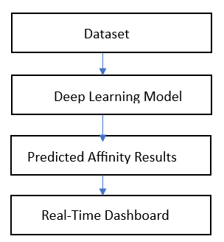

Figure 1. Architecture Diagram

**5. Conclusion**

The proposed system demonstrates how deep learning models, combined with real-time data visualization, can support AI-powered drug discovery. By offering an interactive platform for analyzing predicted molecular properties, the system enables faster decision-making and better understanding of potential drug candidates.